

**Unity Final Project Report**

Submitted to the Department of Game and Mobile Contents

at Keimyung University, Korea

**Head of Department:** Dr. Joon-Jae Lee

**Project Supervisor:** Cathal McCosker

**Submitted by:** Habib - 7000227

Samuel - 7000259

Kevin Deffontaine - 7000250

Kevin Genes - 7000108

**Course ID**: 32829-01

**Date Submitted:** December 2016

Table of Contents

Chapter 1 : Introduction 1

1.1 Background 1

1.2 The task 1

1.3 Game description 2

1.3.1 Game story 2

1.3.2 Game design 2

Chapter 2 : Milestone Guidelines 3

Chapter 3 : Level design 4

3.1 Level description 4

3.2 Script of level 5

Chapter 5 : Playtesting 7

Chapter 5 : Conclusion 8

Chapter 6 : References 9

List of Tables

Table 1: Planning 3

List of Figures

Figure 1: Top view of a level 5

Figure 2: Gameplay showing a tips dialogs 8

Figure 3: Gameplay showing a death animation 8

# Chapter 1 : Introduction

This chapter introduce the report and describe the assignment task.

## 1.1 Background

This document is a report for Unity final project of Fall 2016 at Keimyung University. This report contains a complete description of the game. It’s also describe how do the team approach the work by setting up a planning.

## 1.2 The task

Creation of a video game on the game engine Unity. The game should be fun and enjoyable. It’s must be created with the techniques learned in class.

The player should be guided through the level, be taught how to play and be able to gain skills by playing.

The following is a list of the minimum requirements:

* Contains a Pause and Main Menu
* Explains the control to the player
* Use of Prefabs and Game Objects
* Use of imported meshes for details in levels
* Use of Particles Systems and Animation
* Use of Physics
* Use of Audio
* The player must be able to learn and develop skills and the game should be a bit challenging.

The game should have a good game design to not be too frustrating or too easy. Playtesting the game by non-hardcore gamers is necessary to create such game.

## 1.3 Game description

### 1.3.1 Game story

As a captain of pirate boat, you find yourself in possession of the ultimate treasure. You know the best place to hide it, but it will be a long journey to get there.

Pirates and adventurers have heard about your quest; they would do anything to stop you. Fight for your treasure and your life.

### 1.3.2 Game design

The game take place in the piracy golden age, the player is in control of a boat and have to fight and survive again enemy boats.

The player can navigate his boat with the keyboard and move the camera around the boat with the mouse.

Player and enemy ships have a certain amount of damage they can take before they sink. Animation are played and boats are destroyed. The player can restore a part of his health by looting the scraps of destroyed boats.

Ships can shoot cannonball on each side. Some enemy boat will have mortar and shoot from a long distance to the player.

The player can unlock barrel dropping, they do much more damage but have a cooldown to not be overpowered.

The player can shoot to the left and right side by using the mouse clicks. Enemies and player have unlimited ammo for cannonball and have limited ammo for barrel drop.

The game is made for the player to learn to play gradually, he firstly starts with the only ability to move and look around. The player then gains an upgrade to shoot to the enemies.

To make sure that the player fully understands the different game mechanics, he is blocked by some gates that he can only open by looting a ship that he has to destroy.

The goal of the game is to survive to each level by destroying enemies. In the final level, the player has to defeat an ultimate boss, a Giant Ship that’s spawn enemy ship and shoot to the player.

# Chapter 2 : Milestone Guidelines

This chapter contains the planning of task for each person leading to the finished game.

|  |  |  |  |
| --- | --- | --- | --- |
| **Date** | **Person** | **Task** | **time (h)** |
| 26/11 | Samuel | Creation of the first draft for report | 1 |
| 27/11 | Samuel | Write the rough document and creation of sketches | 5 |
| 28/11 | Kevin Genes | Creation of the game menu | 4 |
| 30/11 | Habib | Write the boat movement script | 4 |
| 01/12 | Kevin Deffontaine | Research, creation and modification of assets | 7 |
| 01/12 | Samuel | Plan each levels | 4 |
| 03/12 | Kevin Deffontaine | Creation of prefabs object | 2 |
| 05/12 | Samuel | Create shooting script | 4 |
| 06/12 | Kevin Genes | Creation of the HUD | 5 |
| 08/12 | Kevin  Deffontaine | Creation of particle system | 2 |
| 07/12 | Habib | Create scraps bonus to repair script | 2 |
| 10/12 | Samuel | Creation of levels in Unity | 6 |
| 10/12 | Habib | Write IA script for enemy ship | 6 |
| 11/12 | Kevin Genes | Creation of the pause menu | 3 |
| 12/12 | Kevin Deffontaine | Creation of animation | 4 |
| 11/12 | Habib | Make playtesting and questionnaires | 4 |
| 15/12 | Samuel | Write final document | 5 |

Table 1: Planning

# Chapter 3 : Level design

This chapter describes how level are designed.

## 3.1 Level description

Every level contains water where the player can navigate, the limitation of the world is made with land and island.

The level is not a straight path, there is multiple obstacles obligating the player to be vigilant of where he is going.

During the level, the player will encounter enemy that will try to sink him. They will appear gradually while the player progress in the level. The player should shoot enemy to destroy them.

Each level is designed to learn a new skill to the player. He will firstly learn to navigate the boat and look around, then he can learn to shoot cannonball, dodge enemy projectile and use their barrel dropping ability.

The controls of the game are explained through the dialogs at each type the player gain new abilities.

The figure 1 shows a view from the top of one of a level.

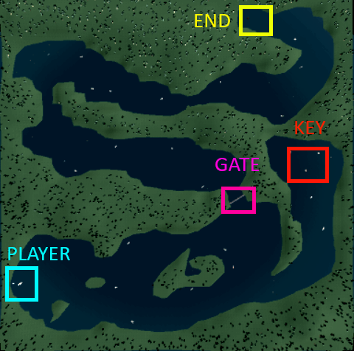

Figure 1: Top view of a level

There is some relief on land and some trees to give the player a better immersion and also to block his view so that he is not seeing too far in the level.

There is a closed gate at the middle of the level, the player has to kill the enemy who have the key. Some enemies are placed gradually through the level.

The goal of the player is at the end of each map.

## 3.2 Script of level

The player appears in the sea, surrounded by lands, his only option is to navigate where there is water.

The player has to travel to the end of level and he also have destroyed the enemy fleet.

The player can pick item dropped by enemies to repair his ship, recover ammo or open a gate to continue the level.

When the player’s ship takes some damage, sound and animation will appear for the player to know he should avoid taking damage.

Trajectory of player’s cannonballs are shown to the player by a line, the player will have to estimate which direction he has to shoot to land a shot on enemy.

Shoot of enemies are repetitive; the player must understand that he can dodge the shot. The game will show some dialogs for giving tips to the player, telling him the story and goal of the game.

# Chapter 5 : Playtesting

Playtesting the game was part of the requirement and is really useful to improve the gameplay.

The game has been play-tested by multiple people in the International Lounge and also tested by “school-external” people to gather feedback.

On the selected filled questionnaire which can be seen on the annexed document, we have different profile of player from people who doesn’t play to video game to some who have experience in it. We really wanted to test our games on multiple types of people and observe them play to figure out what are the problems in the gameplay of our game.

The playtesting was a really good experience for our game, we have adapted our game for the non-hardcore gamer to understand how to play and not to frustrate them. We also improved the game control and the UI from feedbacks of experienced gamer.

# Chapter 5 : Conclusion

On the figure 2 and 3, we can see screenshot of the game, showing some element of the game :

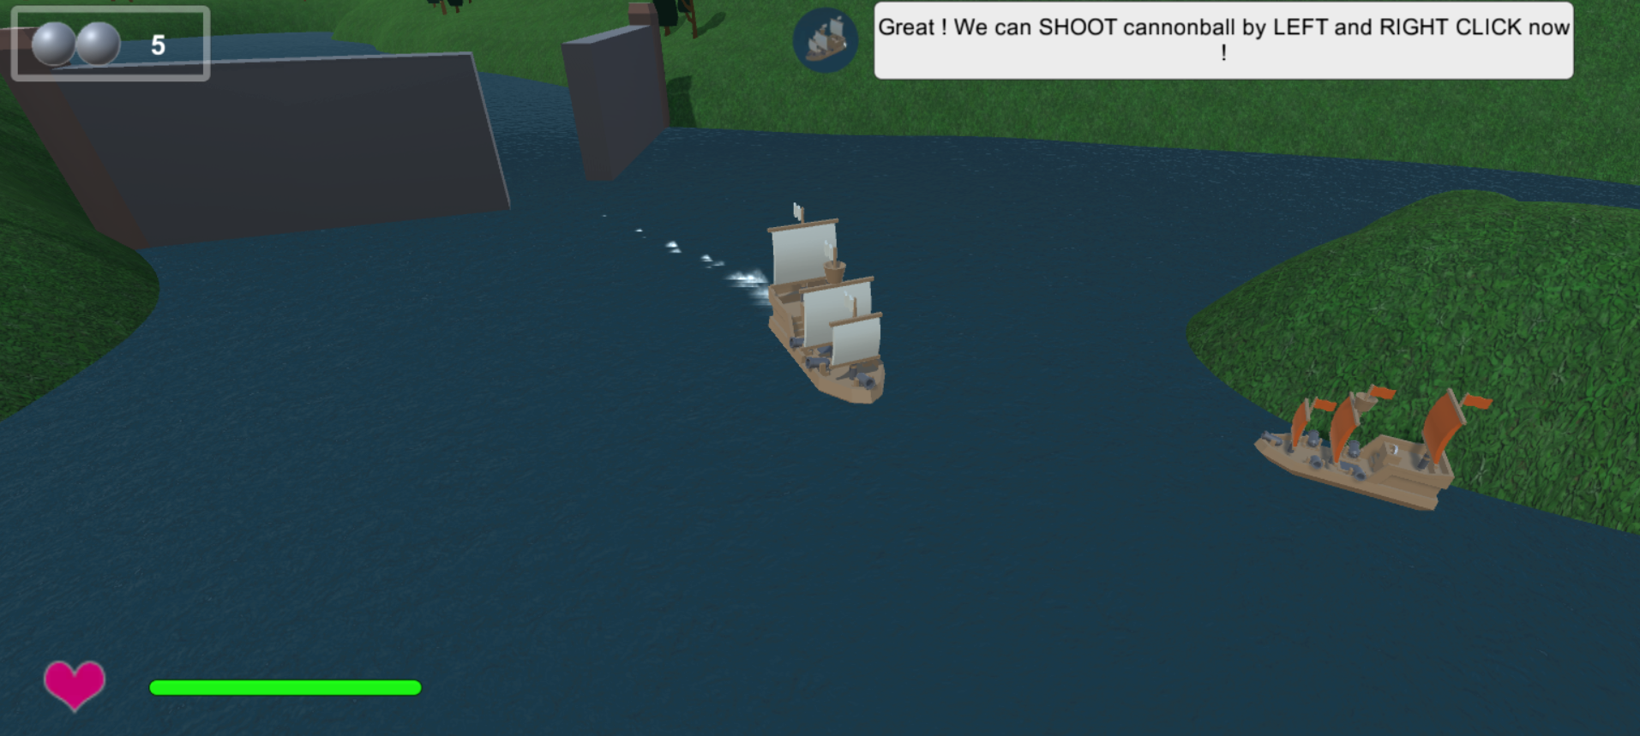

Figure 2: Gameplay showing a tips dialogs

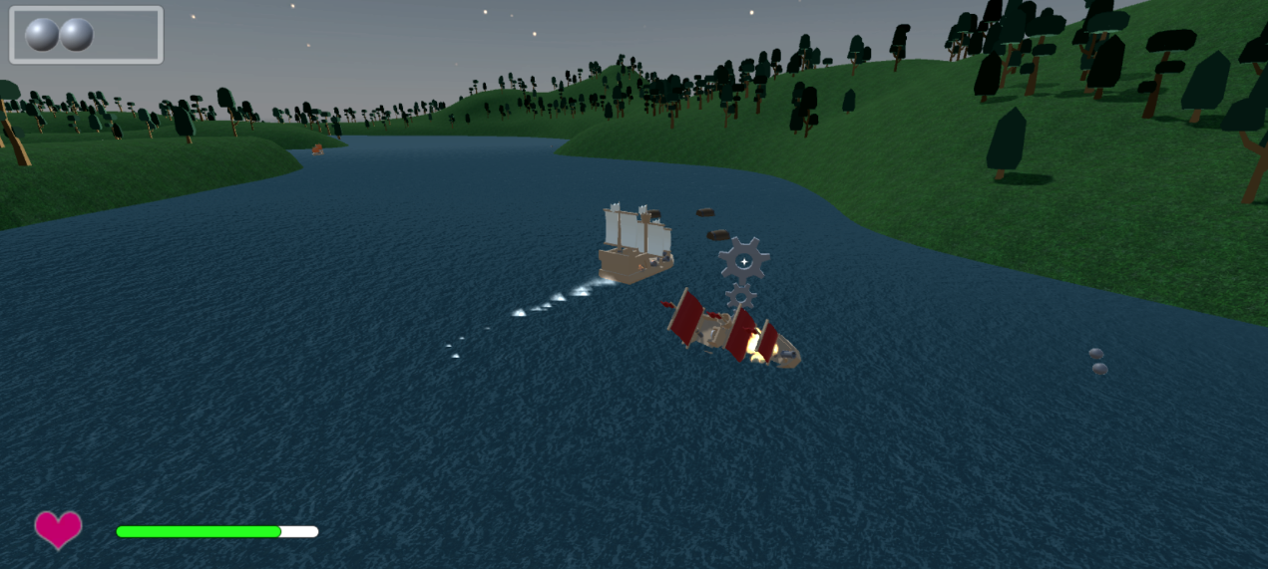

Figure 3: Gameplay showing a death animation

# Chapter 6 : References

The following is a references list of the work used in this project for textures, image and sound assets :

* Fernando Ferreira. End level chest FBX :

<http://tf3dm.com/3d-model/cartoon-chest-29193.html>

* Kenta Nagata. The Great Sea, music menu :

<https://www.youtube.com/watch?v=5J_bL2bjQ-k>

* Shoot sound fx :

<https://www.sounds-resource.com/gamecube/legendofzeldathewindwaker/>

* Menu background image :

<https://www.walldevil.com/wallpapers/w03/thumb/872863-artwork-paint-sail-ship.jpg>

* Kenney. Boats FBX :

<http://kenney.nl/assets/watercraft-pack>

* Kenney. Trees FBX :

<http://kenney.nl/assets/nature-pack-extended>

* Grass texture :

<http://images.naldzgraphics.net/2014/07/12-green-seamless-grass-texture.jpg>